SOFTWARE REQUIREMENTS SPECIFICATION

CLINIC INFORMATION SYSTEM

PREPARED BY:

CASTILLO, WILL

DE LA VEGA, MCKAY

HEROMAN, JENA

PARKER, TRACE

STANFILL, BRYCE

Table of Contents

1.0 Introduction 3

1.1 Preface 4

1.2 Purpose 4

1.3 Scope of Project 4

1.4 Definitions and Acronyms 4

1.5 Assumptions and Dependencies 4

2.0 Overall Description 6

2.1.00 System Environment 6

2.1.01 Context Model 6

2.1.02 Observer Design Pattern 7

2.1.03 Model-View-Controller 7

2.2 Use Cases Overview 9

2.3 Use Cases Section 10

2.3.1 Clinic Receptionist Use Cases 10

2.3.1.00 Login Use Case 10

2.3.1.01 Logout Use Case 10

2.3.1.02 View Patient Info Use Case 10

2.3.1.03 Add Patient Use Case 11

2.3.1.04 Delete Patient Use Case 11

2.3.1.05 View Patient Records Use Case 12

2.3.1.06 Issue Copay Use Case 12

2.3.1.07 Manage Appointment Use Case 12

2.3.1.08 Add Appointment Use Case 13

2.3.1.09 Delete Appointment Use Case 13

2.3.2 PA Use Cases 13

2.3.2.00 Prescribe Medicine Use Case 13

2.3.2.01 Issue Treatment Use Case 14

2.3.2.02 Create Referral Use Case 14

2.3.2.03 View e-Tapper-S Reports Use Case 14

2.3.3 Patient Use Cases 15

2.3.3.00 Request Appointment Use Case 15

2.3.3.01 Check-in Appointment Use Case 15

2.4 User Characteristics 15

3.0 Requirements Specification 16

3.1 Non-Functional Requirements 16

3.1.00 Performance 16

3.1.01 Reliability 16

3.1.02 Availability 16

3.1.03 Maintainability 16

3.1.04 Recoverability 16

3.1.05 Capacity 16

3.1.06 Security 16

3.1.07 Data Integrity 16

3.1.08 Usability 16

3.2 Functional Requirements 17

3.2.00 Login 17

3.2.01 Logout 17

3.2.02 View Patient Info 17

3.2.03 Add Patient 18

3.2.04 Delete Patient 18

3.2.05 View Patient Records 19

3.2.06 Issue Copay 19

3.2.07 Manage Appointment 20

3.2.08 Add Appointment 21

3.2.09 Delete Appointment 22

3.2.10 Prescribe Medicine 22

3.2.11 Issue Treatment 23

3.2.12 Create Referral 23

3.2.13 View e-Tapper-S Reports 24

3.2.14 Request Appointment 25

3.2.15 Check-in Appointment 26

3.3 Sequence Diagrams 27

3.3.00 Login Sequence Diagram 27

3.3.01 Logout Sequence Diagram 27

3.3.02 View Patient Info Sequence Diagram 28

3.3.03 Add Patient Sequence Diagram 28

3.3.04 Delete Patient Sequence Diagram 29

3.3.05 View Patient Records Sequence Diagram 29

3.3.06 Issue Copay Sequence Diagram 30

3.3.07 Manage Appointment Sequence Diagram 30

3.3.08 Add Appointment Sequence Diagram 31

3.3.09 Delete Appointment Sequence Diagram 31

3.3.10 Prescribe Medicine Sequence Diagram 32

3.3.11 Issue Treatment Sequence Diagram 32

3.3.12 Create Referral Sequence Diagram 33

3.3.13 View e-Tapper-S Reports 33

3.3.14 Request Appointment Sequence Diagram 34

3.3.15 Check-in Appointment Sequence Diagram 34

3.4 State Diagrams 35

3.4.00 Home Screen State Diagram 35

3.4.01 View Patient Info State Diagram 36

3.4.02 Add Patient State Diagram 37

3.4.03 Delete Patient State Diagram 37

3.4.04 View Patient Record State Diagram 38

3.4.05 Patient Billing State Diagram 38

3.4.06 Manage Appointment State Diagram 39

3.4.07 Issue Treatment State Diagram 40

3.4.16 Request Appointment State Diagram 40

3.4.17 Check-in Appointment State Diagram 41

4.0 Implementation 42

4.1 Reuse 42

4.2 Configuration Management 42

4.3 Host-Target Development 42

5.0 Testing 43

5.1 Functional Requirements Test Scenarios 43

5.2 Release Testing 44

5.3 User Testing 45

5.3.1 Acceptance Criteria 45

# 

# 1.0 Introduction

### 1.1 Preface

This document's intent is to present a detailed description of the Clinic Information System. This document will explain the purpose and features of the system, the interfaces of the system, what the system will do, and the constraints under which it must operate. This document is intended for both the stakeholders and the developers of the system.

### 1.2 Purpose

The Clinic Information System is an organized system designed to provide staff and administrators with a platform for managing operations and activities through a feature rich interface.

### 1.3 Scope of Project

The Clinic Information System will manage admittance and discharge of patients at the clinic, manage patient records, process insurance and billing information, process referrals to specialists and hospitals, and manage appointment bookings. The Clinic Information System will have an internal interface designed to provide the clinic’s staff with a platform to conduct operations. The system will also have an external interface designed to provide patients with an access point to schedule an appointment or check-in upon arrival.

The Clinic Information System will have a dedicated internal database for the explicit purpose of storing the credentials of users of the system and the e-Tapper-S reports uploaded by the patients. The purpose of this internal database is to minimize the risk of attacks to highly sensitive information and reduce attack vectors. The external database the Clinic Information System connects to also serves doctor’s offices and hospitals, and as such, the external database is positioned to be at a greater risk of attacks from malicious actors.

Furthermore, the e-Tapper-S is fully integrated into the Clinic Information System. Patients who have the e-Tapper-S Mobile App can upload the results of their treatments to the Clinic Information System.

### 1.4 Definitions and Acronyms

|  |  |
| --- | --- |
| **Term** | **Definition** |
| API | Application Programming Interface |
| CIS | Clinic Information System |
| Database (DB) | An organized collection of structured information |
| DBA | Database Administrator |
| GUI | Graphical User Interface |
| PA | Physician's Assistant |
| SRS | A document that describes what the software will do and how it will be expected to perform. For example, this document |

### 1.5 Assumptions and Dependencies

The requirements of this SRS assume that the developers have previous software that serves as the basis for the development of the Clinic Information System. This is discussed further in section 4.1.

The requirements of this SRS assume that the CIS has an API for the e-Tapper-S Mobile App that allows us to receive data from patient’s e-Tapper-S treatments.

# 2.0 Overall Description

### 2.1.00 System Environment

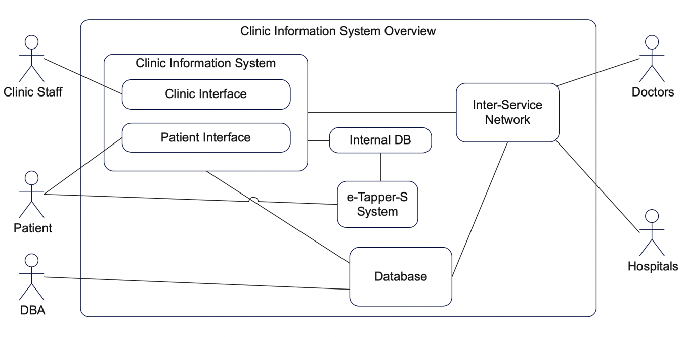

### 2.1.01 Context Model

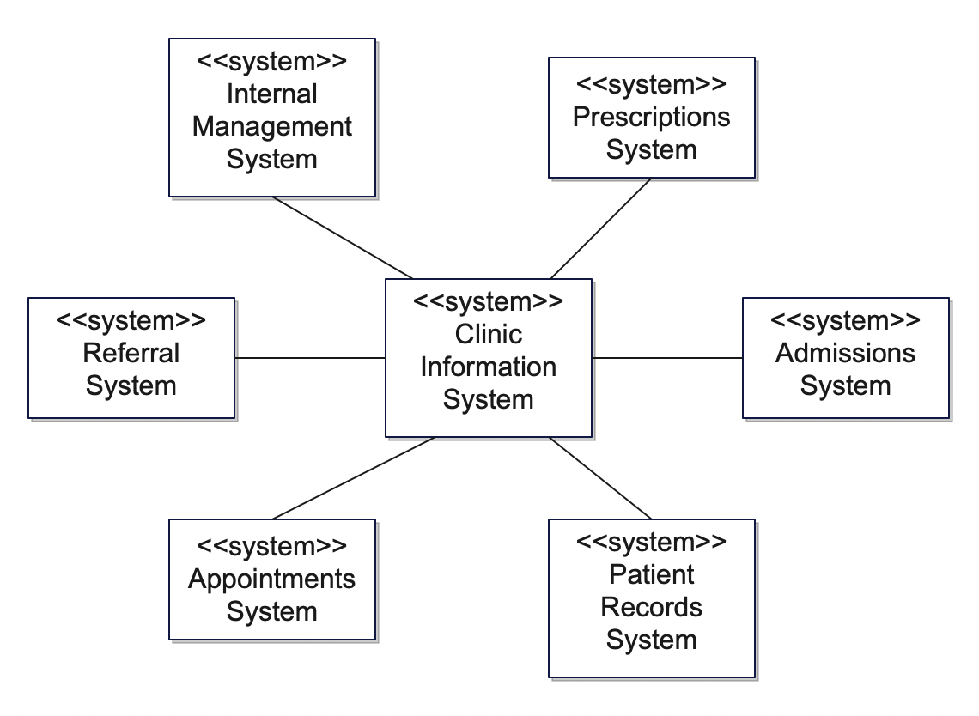

### 2.1.02 Observer Design Pattern

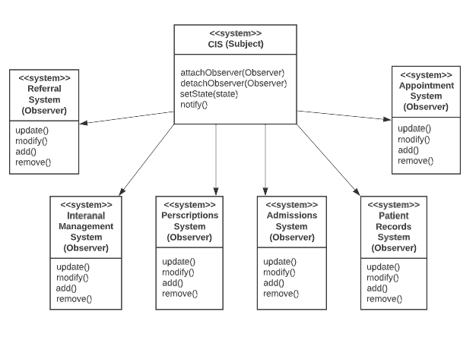

### 2.1.03 Model-View-Controller

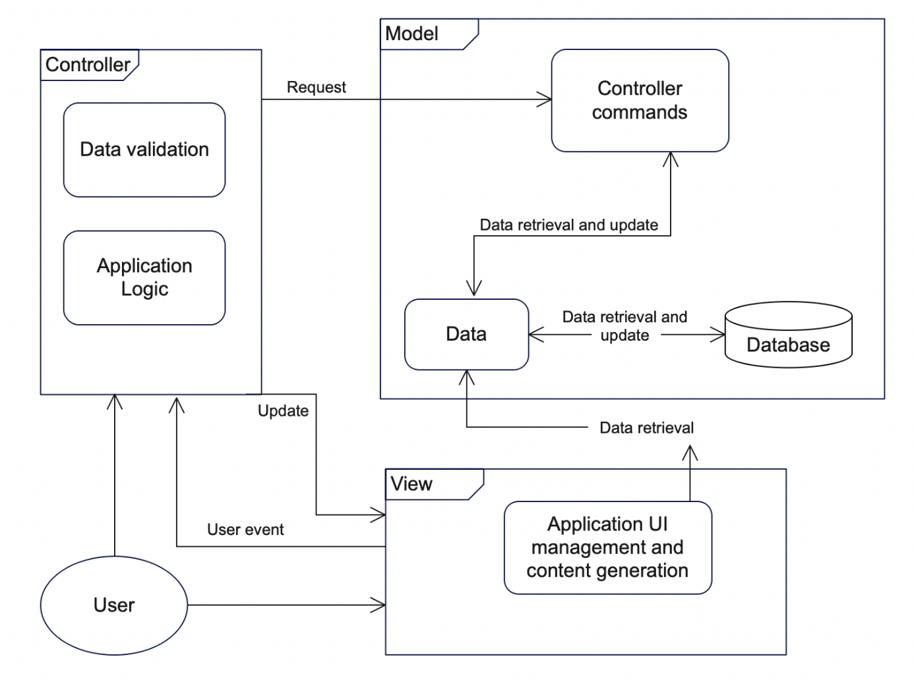

## 2.2 Use Cases Overview

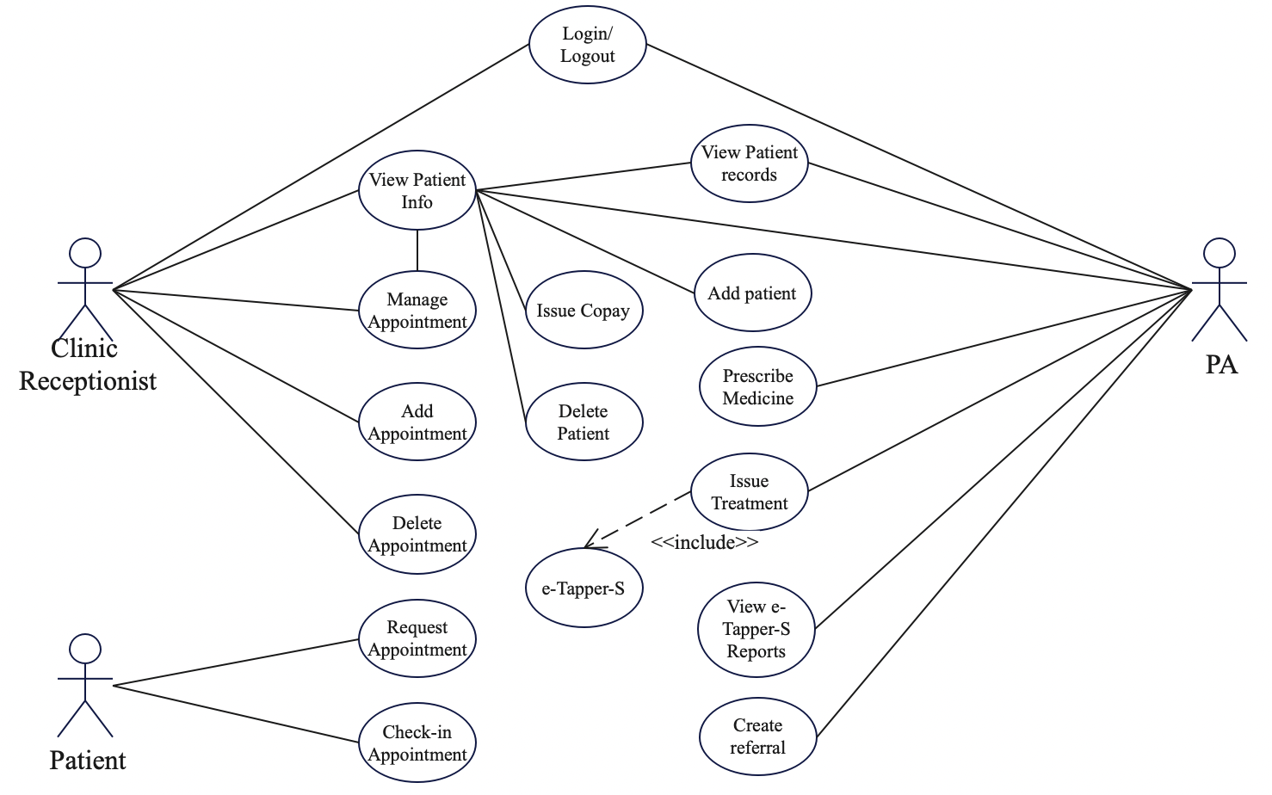

## 2.3 Use Cases Section

This section will describe the use cases outlined in the Use Cases Overview.

## 2.3.1 Clinic Receptionist Use Cases

### 2.3.1.00 Login Use Case

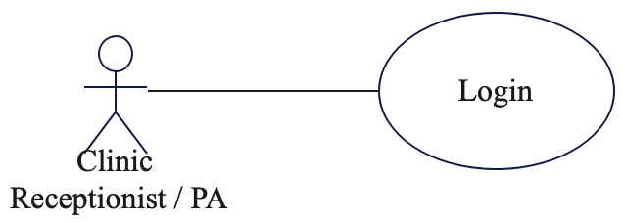

Description:

When the user is on the welcome screen, the system shall display a form for the user to input their username and password. If the credentials are correct, the system shall take the user to the home screen. The system shall record the time and date of the login. If the credentials are incorrect, the system shall notify the user as such. The system shall allow 3 attempts to login per username before locking the username out and requiring administrative approval to unlock.

### 2.3.1.01 Logout Use Case

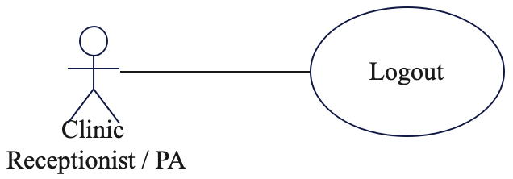

Description:

The system shall provide a toolbar that is always accessible to the user. The toolbar shall have the option to logout from the system. When a user logs out, the system shall return to the welcome screen. The system shall record the time and date of the logout.

### 2.3.1.02 View Patient Info Use Case

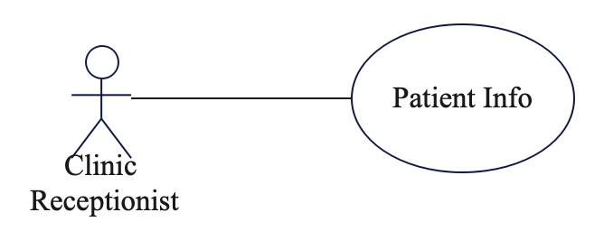

Description:

When the user is on the home screen of the CIS, the system shall provide the user with a Patient Info module. Clicking on the Patient Info module will take the user to a screen that allows the user to begin searching for a patient by typing in the last name of the patient. As the user begins to type, a drop-down list will begin to populate. When a patient is selected from the list, the system shall take the user to a screen displaying the patient’s Information.

### 2.3.1.03 Add Patient Use Case

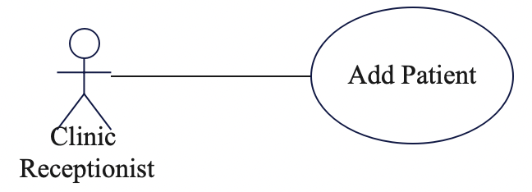

Description:

When the user is on the home screen of the CIS, the system shall provide the user with an Add Patient module. Clicking on the Add Patient module will take the user to a screen that allows the user to input the new patient's credentials. If all the required fields are filled in, the system shall allow the user to submit the information for the new patient. The system shall ask the user to confirm that the new patient information is correct. When the user confirms that the information is correct, the system shall update the system with the new patient and record the time and date of the new entry.

### 2.3.1.04 Delete Patient Use Case

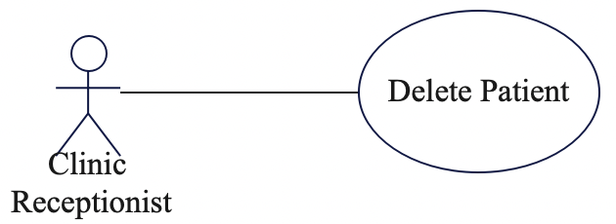

Description:

When the user is on the home screen of the CIS, the system shall provide the user with a Delete Patient module. Clicking on the Delete Patient module will take the user to a screen that allows the user to remove a patient from the system. The system shall present the user with a form to fill out the patient that is to be deleted. The system shall require the user to input the patient’s first name, last name, and date of birth. The system shall not display a patient list to prevent accidental deletion. When the required fields are completed, the system shall retrieve the patient as described. The system shall display the patient’s record and present the user with an option to delete the patient. The system shall confirm with the user that this process cannot be reversed.

### 2.3.1.05 View Patient Records Use Case

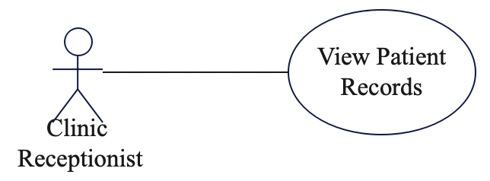

Description:

When the user is on a patient’s information screen, the system shall have a module to access the patient’s records. When the user clicks on the Patient Records module, the system shall display a list of all the patient’s records that are in the system.

### 2.3.1.06 Issue Copay Use Case

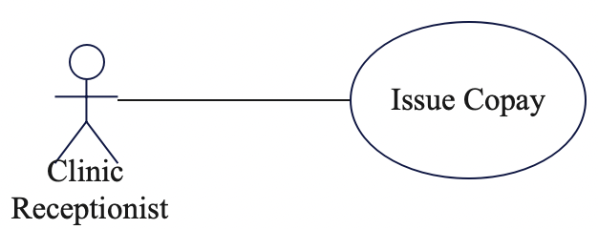

Description:

When the user is on a patient’s information screen, the system shall have a module to issue a copay for services rendered. The system shall display a summary of the services provided for the patient and the costs associated with each service.

### 2.3.1.07 Manage Appointment Use Case

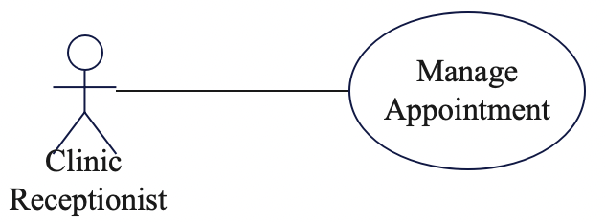

Description:

When the user is on a patient’s appointment screen, the system shall have a module that allows the user to manage the existing appointment. When the user clicks on the Manage Appointment module, the system shall display the details of the appointment. The user may edit the date and time of the appointment or cancel the appointment. The system shall allow the user to submit the changes. The system shall ask the user to confirm the changes to the appointment.

### 2.3.1.08 Add Appointment Use Case

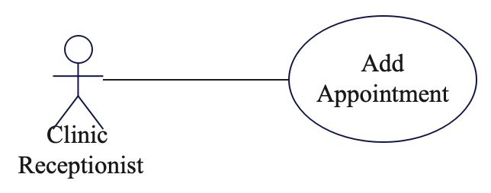

Description

When the clinic receptionist receives an appointment request from a patient, the receptionist shall add the patient and their scheduled time and date to the appointment system. If the patient's name, scheduled date, and time are valid, then the appointment system shall create the appointment listing in the appointment system. This can be performed with an added patient module initiated from the clinic receptionist.

### 2.3.1.09 Delete Appointment Use Case

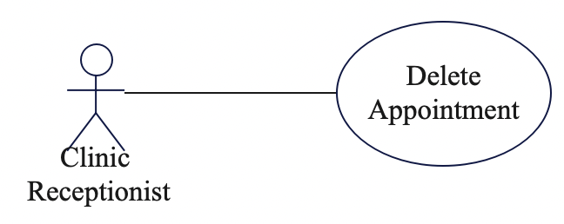

Description

If the clinic receptionist receives a request from a patient to cancel a scheduled appointment, the clinic receptionist shall be able to do so in the appointment management system. This should have a module that the receptionist can interact with to make the deletion. The system shall also confirm to the receptionist that this deletion cannot be undone.

## 2.3.2 PA Use Cases

### 2.3.2.00 Prescribe Medicine Use Case

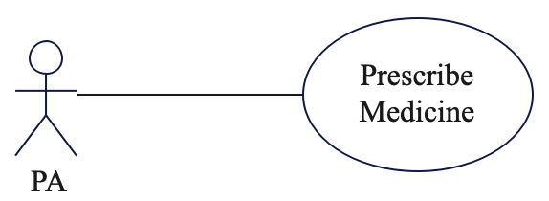

Description:

The PA shall be allowed to prescribe medicine to the patient based off recent appointments, records, and e-Tapper-S results. The PA shall then be able to request medication and update patient records regarding the current prescription. This shall be done in modules in the medication management system and patient record system, respectively.

### 2.3.2.01 Issue Treatment Use Case



Description:

The PA shall be allowed to issue treatment to the patient depending on their severity. Treatment shall be issued through the e-Tapper-S if applicable or through traditional medical procedures.

### 2.3.2.02 Create Referral Use Case



Description:

The PA shall be allowed to access the referral subsystem of the CIS and schedule an appointment for the patient if the patient is not improving in symptoms or is in more serious condition. The referral system shall be allowed to look through hospitals or private practices that can help suit the patient’s needs.

### 2.3.2.03 View e-Tapper-S Reports Use Case



Description:

The PA shall be allowed to access patient e-Tapper-S reports from the patient’s sent e-Tapper-S records from the e-Tapper-S mobile application and after treatment with the e-Tapper-S in the clinic. The system shall provide an e-Tapper-S module.

## 2.3.3 Patient Use Cases

### 2.3.3.00 Request Appointment Use Case

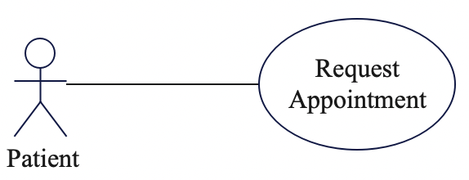

Description:

The patient shall be allowed to schedule an appointment for the clinic by requesting one through the appointment management system. If the appointment is invalid, the patient shall not be allowed to confirm the appointment.

### 2.3.3.01 Check-in Appointment Use Case

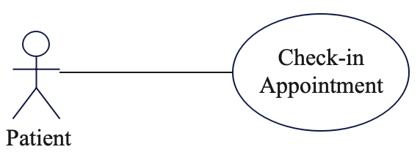

Description:

The patient shall be allowed to check-in to the clinic for a walk-in or scheduled appointment.

## 2.4 User Characteristics

The user is expected to be desktop and internet literate, capable of interacting with a GUI, navigating menus, modifying information, submitting reports, and completing similar tasks.

# 3.0 Requirements Specification

## 3.1 Non-Functional Requirements

### 3.1.00 Performance

The system should take no more than 1 second for users to select between screens and submit operations.

### 3.1.01 Reliability

Users should be able to access the features of the system no less than 99% of the time without failure.

### 3.1.02 Availability

Users should have access to the system and associated features 24 hours per day. In the event of unplanned system downtime, operations should resume within 2 hours.

### 3.1.03 Maintainability

Scheduled maintenance should not interrupt services for more than 1 hour.

### 3.1.04 Recoverability

In the case of major system outages or data corruption, services should be in full operation and data restored within 2 business days.

### 3.1.05 Capacity

Data storage for the internal database shall never exceed 90% capacity. Additional storage shall be implemented as necessary.

### 3.1.06 Security

User data shall be encrypted to secure against malicious actors and leaks.

### 3.1.07 Data Integrity

The system servers shall be maintained with redundancy to prevent loss of data.

### 3.1.08 Usability

The features of the system should be user-friendly and easy to use.

## 3.2 Functional Requirements

### 3.2.00 Login

|  |  |
| --- | --- |
| **Use Case Name** | Login |
| **XRef** | Section 2.3.1.00 |
| **Trigger** | The user submits the correct credentials. |
| **Precondition(s)** | There is no user logged in.  The welcome screen is displayed. |
| **Basic Path** | 1. The user inputs their username and password. 2. The credentials are verified by the system and the user is taken to the home screen. |
| **Alternative Path(s)** | None |
| **Postcondition(s)** | The time and date of the login is recorded.  The user is logged in |
| **Exception Path** | The user may abandon the operation at any time. |
| **Other** | None |

### 3.2.01 Logout

|  |  |
| --- | --- |
| **Use Case Name** | Logout |
| **XRef** | Section 2.3.1.01 |
| **Trigger** | The user selects logout from the toolbar. |
| **Precondition(s)** | The user is logged in. |
| **Basic Path** | 1. The user navigates to the toolbar and selects logout. 2. The system asks the user to confirm. 3. The user is logged out and the welcome screen is displayed. |
| **Alternative Path(s)** | None |
| **Postcondition(s)** | The time and date of the logout is recorded.  The user is logged out. |
| **Exception Path** | The user may abandon the operation at any time. |
| **Other** | None |

### 3.2.02 View Patient Info

|  |  |
| --- | --- |
| **Use Case Name** | View Patient Info |
| **XRef** | Section 2.3.1.02 |
| **Trigger** | The user selects the Patient module. |
| **Precondition(s)** | The user is on the home screen of the CIS. |
| **Basic Path** | 1. The user selects the Patient module. 2. The user begins typing the patient’s last name. 3. As the user is typing, a list of patients will begin to populate the drop-down menu. The user selects the desired patient. 4. The CIS asks the user to confirm the patient. 5. The patient’s info page is displayed. |
| **Alternative Path(s)** | The user may open a patient’s info from the Appointments module if the patient has been previously registered. |
| **Postcondition(s)** | 1. The patient’s info page is displayed to the user. 2. The system records the time and date the information was accessed. |
| **Exception Path** | The user may abandon the operation at any time. |
| **Other** | None |

### 3.2.03 Add Patient

|  |  |
| --- | --- |
| **Use Case Name** | Add Patient |
| **XRef** | Section 2.3.1.03 |
| **Trigger** | The user selects the New Patient module. |
| **Precondition(s)** | The user is on the home screen of the CIS. |
| **Basic Path** | 1. The user selects the Add Patient module. 2. The user inputs the information about the patient into the required fields. 3. The user submits the completed form. 4. The system asks the user to confirm that the information is correct. 5. The user confirms the information is correct and selects the Confirm button. |
| **Alternative Path(s)** | None |
| **Postcondition(s)** | 1. A new patient is added to the system. 2. The time and date of the added entry is recorded. |
| **Exception Path** | The user may abandon the operation at any time. |
| **Other** | None |

### 3.2.04 Delete Patient

|  |  |
| --- | --- |
| **Use Case Name** | Delete Patient |
| **XRef** | Section 2.3.1.04 |
| **Trigger** | The user selects the Delete Patient button |
| **Precondition(s)** | The user is on a patient’s info page. |
| **Basic Path** | 1. The user selects the Delete Patient module from the patient records system of the CIS. 2. The user must authenticate their identity again. 3. The user then selects the confirmation button and the patient selected is deleted from the clinical records. |
| **Alternative Path(s)** | 1. The patient does not exist, in which an error message will be displayed to the user. |
| **Postcondition(s)** | 1. The patient is deleted from the CIS. |
| **Exception Path** | The user may abandon the operation at any time. |
| **Other** | None |

### 3.2.05 View Patient Records

|  |  |
| --- | --- |
| **Use Case Name** | View Patient Records |
| **XRef** | Section 2.3.1.05 |
| **Trigger** | A PA or doctor logins into the patient record system of the CIS and clicks a patient profile. |
| **Precondition(s)** | * Receptionist has a valid login for the CIS. |
| **Basic Path** | 1. Receptionist logs into the CIS system. 2. CIS validates the receptionist's credentials. 3. Receptionist queries the patient's medical record in the CIS. 4. CIS retrieves patient information from the database. 5. CIS displays patient records for receptionists to view. |
| **Alternative Path(s)** | None |
| **Postcondition(s)** | * The receptionist has viewed the patient's medical record. |
| **Exception Path** | The user may abandon the operation at any time. |
| **Other** | None |

### 3.2.06 Issue Copay

|  |  |
| --- | --- |
| **Use Case Name** | Issue Copay |
| **XRef** | Section 2.3.1.06 |
| **Trigger** | The receptionist requests to charge the co-pay for a patient's appointment. |
| **Precondition(s)** | * The receptionist has a valid login for the CIS. * The patient has an upcoming appointment scheduled at the clinic. |
| **Basic Path** | 1. The receptionist logs into the CIS. 2. The CIS validates the receptionist's credentials. 3. The receptionist requests the patient's appointment information from the CIS. 4. The CIS displays the patient's appointment information. 5. The receptionist charges the co-pay to the patient's profile in the CIS. 6. The CIS validates the amount of the co-pay charged. |
| **Alternative Path(s)** | N/A |
| **Postcondition(s)** | * The co-pay amount is charged to the patient's profile in the CIS. |
| **Exception Path** | The user may abandon the operation at any time. |
| **Other** | N/A |

### 3.2.07 Manage Appointment

|  |  |
| --- | --- |
| **Use Case Name** | Manage Appointment |
| **XRef** | Section 2.3.1.07 |
| **Trigger** | * Receptionist needs to manage a patient's appointment. |
| **Precondition(s)** | * Receptionist has credential to access the CIS. * The patient exists in the CIS. |
| **Basic Path** | 1. A receptionist selects the patient's appointment record in the CIS. 2. CIS displays the patient's appointment details. 3. Receptionist can choose to edit, delete, or add an appointment.  * If editing, Receptionist updates the date and time of the appointment. * If adding, the Receptionist creates a new appointment with a date and time.  1. CIS saves the changes to the appointment in the database. 2. CIS displays the updated appointment details. |
| **Alternative Path(s)** | 1. If the patient is not found in the CIS, Receptionist can add a new patient to the system.   1.1 Receptionist enters the patient's information into the CIS.  1.2 CIS saves the patient's information to the database.  1.3 Receptionist proceeds to step 3. |
| **Postcondition(s)** | * The appointment information is updated in the CIS database. |
| **Exception Path** | The user may abandon the operation at any time. |
| **Other** | N/A |

### 3.2.08 Add Appointment

|  |  |
| --- | --- |
| **Use Case Name** | Add Appointment |
| **XRef** | Section 2.3.1.08 |
| **Trigger** | The user requests to add an appointment to the system. |
| **Precondition(s)** | * The user is authenticated and authorized to add appointments. * User has necessary information to schedule the appointment, including patient information, healthcare provider availability, and desired date and time. |
| **Basic Path** | 1. The user accesses the CIS to find an available date and time for the patient's appointment. 2. CIS confirms the availability of the selected date and time. 3. User schedules the patient's appointment for the selected date and time. 4. CIS updates the appointment database with the new appointment details. 5. Database confirms the update to CIS. 6. CIS notifies the user of the successful scheduling of the appointment. |
| **Alternative Path(s)** | * If the appointment time and date is not valid, such as an already past date, an error message shall be displayed saying invalid date. * If the user tries to schedule an appointment that has already been confirmed, display an error message saying that the appointment time is already booked |
| **Postcondition(s)** | * The appointment database has been updated with the new appointment details. * The user has been notified of the successful addition of the appointment. |
| **Exception Path** | The user may abandon the operation at any time. |
| **Other** | N/A |

### 3.2.09 Delete Appointment

|  |  |
| --- | --- |
| **Use Case Name** | Delete Appointment |
| **XRef** | Section 2.3.1.09 |
| **Trigger** | The user selects the delete appointment button. |
| **Precondition(s)** | The appointment exists in the system. |
| **Basic Path** | 1. The user selects the Appointments module from the home screen. 2. The user selects the appointment that is to be deleted. 3. The user selects the delete appointment button. 4. The user confirms the deletion of the appointment. |
| **Alternative Path(s)** | None |
| **Postcondition(s)** | The appointment is removed from the system. |
| **Exception Path** | The user may abandon the operation at any time. |
| **Other** | None |

### 3.2.10 Prescribe Medicine

|  |  |
| --- | --- |
| **Use Case Name** | Prescribe Medicine |
| **XRef** | Section 2.3.2.00 |
| **Trigger** | Doctor determines patient requires medicine. |
| **Precondition(s)** | * PA has a valid login for the Clinic Information System. |
| **Basic Path** | 1. PA logs into CIS. 2. CIS validates PA credentials. 3. PA queries the patient's medical record from the CIS system. 4. CIS returns the patient's record. 5. The PA enters medication details such as dosage, frequency, and duration of treatment in the CIS. 6. CIS confirms the medication details. 7. The PA requests a prescription from the CIS system. 8. CIS updates the patient's record in the database. 9. The database confirms the update to the CIS system. |
| **Alternative Path(s)** | N/A |
| **Postcondition(s)** | * The patient's medical record is updated to include the prescription information. |
| **Exception Path** | The user may abandon the operation at any time. |
| **Other** | N/A |

### 3.2.11 Issue Treatment

|  |  |
| --- | --- |
| **Use Case Name** | Issue Treatment |
| **XRef** | Section 2.3.2.01 |
| **Trigger** | * Doctor determines a patient requires a treatment plan. |
| **Precondition(s)** | * Patient is registered in the system. * The patient has been diagnosed and evaluated by the doctor. * PA has access to CIS. * The PA has determined a treatment plan for the patient. |
| **Basic Path** | 1. PA searches for the patient's record in the CIS. 2. CIS confirms patient record is available. 3. PA gathers necessary personnel and items for the treatment. 4. Treatment is issued to the patient. |
| **Alternative Path(s)** | 3.1 If the treatment can be performed using an E-tapper machine, the PA can download the patient's E-tapper-s profile from the CIS.  3.2 PA configures the E-tapper machine to perform the treatment.  3.3 Treatment is issued to the patient using the E-tapper machine. |
| **Postcondition(s)** | * Treatment issued successfully to the patient and updated in the patient's medical record in the CIS. |
| **Exception Path** | The user may abandon the operation at any time. |
| **Other** | N/A |

### 3.2.12 Create Referral

|  |  |
| --- | --- |
| **Use Case Name** | Create Referral |
| **XRef** | Section 2.3.2.02 |
| **Trigger** | * A healthcare provider determines that a patient needs to see a specialist for further evaluation or treatment. |
| **Precondition(s)** | * PA is authorized to make referrals on behalf of the healthcare provider. * PA has access to the CIS and patient's medical records. |
| **Basic Path** | 1. PA logs into CIS. 2. CIS validates PA credentials. 3. PA provider selects patient who needs a referral. 4. PA selects a specialist and enters referral details. 5. CIS confirms the referral request and sends it to the selected specialist. 6. CIS updates the patient's medical record with the referral information. |
| **Alternative Path(s)** | 1. If the specialist is not available, the healthcare provider selects an alternate specialist from the list. |
| **Postcondition(s)** | * The patient's medical record is updated with the referral information. * The specialist receives the referral request and contacts the patient to schedule an appointment. |
| **Exception Path** | The user may abandon the operation at any time. |
| **Other** | N/A |

### 3.2.13 View e-Tapper-S Reports

|  |  |
| --- | --- |
| **Use Case Name** | View e-Tapper-S Reports |
| **XRef** | Section 2.3.2.035 |
| **Trigger** | * The PA requests access to the patient's E-tapper-s profile through the CIS. |
| **Precondition(s)** | * The PA has a valid login for the Clinic Information System. * The PA has permission to access the patient's e-Tapper-S profile. * The patient's e-Tapper-S profile is stored in the database and is accessible through the CIS. |
| **Basic Path** | 1. PA logs into CIS. 2. CIS validates PA credentials. 3. PA requests to download the patient's E-tapper-s profile in the CIS. 4. CIS confirms the request. 5. PA is granted access to download the patient's E-tapper-s profile. |
| **Alternative Path(s)** | * If the PA's credentials are invalid, the CIS will deny access to the system and prompt the user to re-enter their credentials. * If the PA does not have permission to access the patient's E-tapper-s profile, the CIS will deny access. |
| **Postcondition(s)** | * The PA has successfully downloaded the patient's e-Tapper-S profile from the CIS. * The PA can view the patient's medical information. |
| **Exception Path** | The user may abandon the operation at any time. |
| **Other** | N/A |

### 3.2.14 Request Appointment

|  |  |
| --- | --- |
| **Use Case Name** | Request Appointment |
| **XRef** | Section 2.3.3.00 |
| **Trigger** | Patient requests an appointment with a healthcare provider. |
| **Precondition(s)** | * Patient is registered in the system |
| **Basic Path** | 1. User logs in to the system. 2. User navigates to the appointment scheduling section. 3. User selects the desired healthcare provider. 4. User selects the appointment type and preferred date and time. 5. System verifies the healthcare provider's availability. 6. System confirms the appointment details to the user. 7. User confirms the appointment. 8. System schedules the appointment and sends a confirmation to the user. |
| **Alternative Path(s)** | 5. If the healthcare provider is not available, the user can modify them.  6. If the appointment details are incorrect, the user can modify them. |
| **Postcondition(s)** | * Appointment is scheduled and confirmed. * User receives confirmation of appointment. |
| **Exception Path** | The user may abandon the operation at any time. |
| **Other** | N/A |

### 3.2.15 Check-in Appointment

|  |  |
| --- | --- |
| **Use Case Name** | Check-in Appointment |
| **XRef** | Section 2.3.3.01 |
| **Trigger** | Patient arrives for a scheduled appointment. |
| **Precondition(s)** | * Patient has an existing appointment in the system. |
| **Basic Path** | 1. Patient arrives at the clinic and checks in with the receptionist, indicating they have a scheduled appointment. 2. The receptionist confirms the patient's identity and appointment details. 3. Receptionist gives the patient any necessary medical paperwork to fill out and complete. 4. Patient returns the completed medical paperwork to the receptionist. 5. Receptionist updates the patient's information in the system based on the completed paperwork. 6. System confirms the patient's check-in for the scheduled appointment. 7. Patient sees the healthcare provider at the scheduled appointment time. |
| **Alternative Path(s)** | None |
| **Postcondition(s)** | * Patient is marked as checked-in for the appointment. * Appointment status is updated to "Checked-in". * Patient's information in the system is up to date. * The receptionist has confirmed the patient's identity and appointment details. |
| **Exception Path** | The user may abandon the operation at any time. |
| **Other** | None |

## 3.3 Sequence Diagrams

### 3.3.00 Login Sequence Diagram

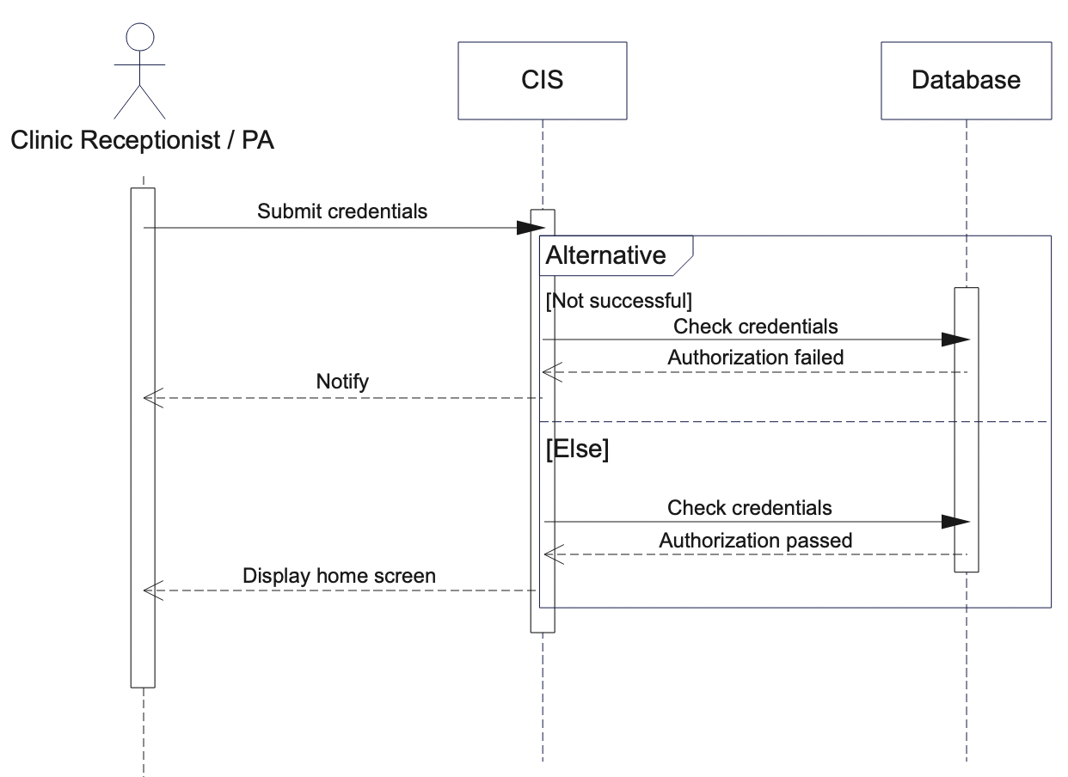

### 3.3.01 Logout Sequence Diagram

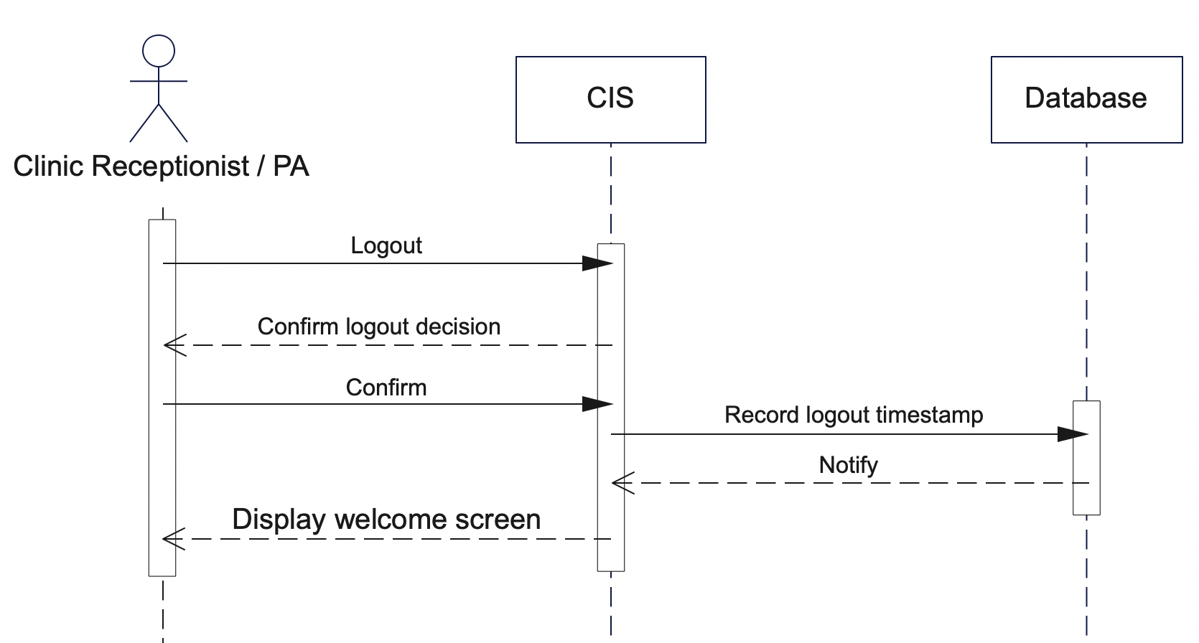

### 3.3.02 View Patient Info Sequence Diagram

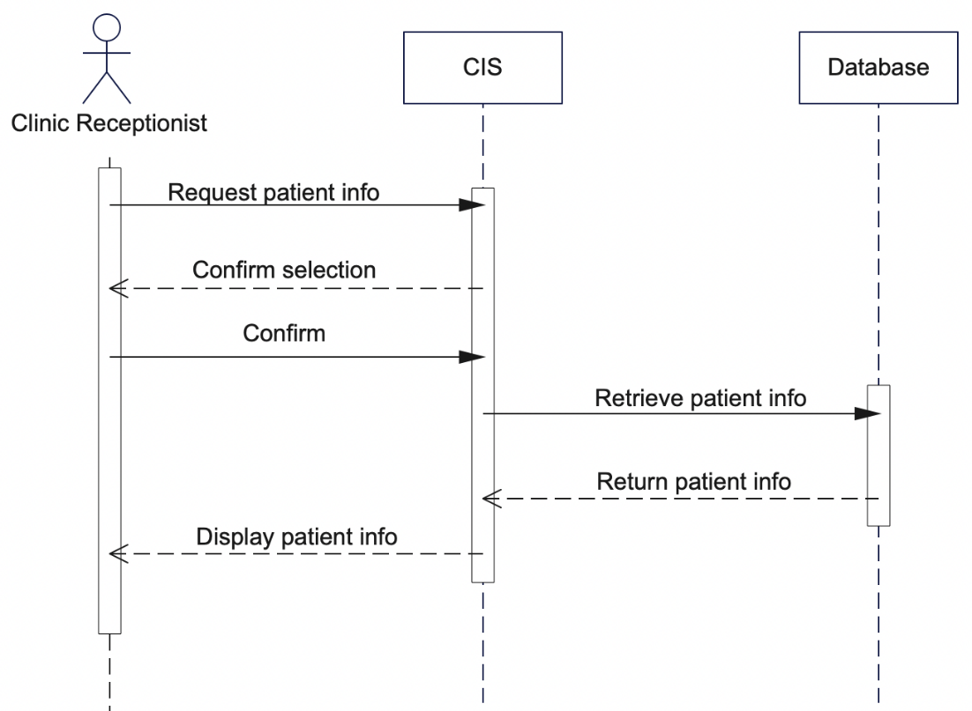

### 3.3.03 Add Patient Sequence Diagram

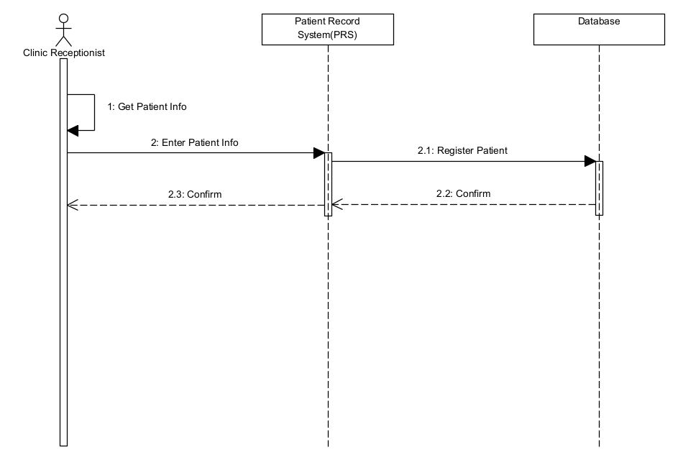

### 3.3.04 Delete Patient Sequence Diagram

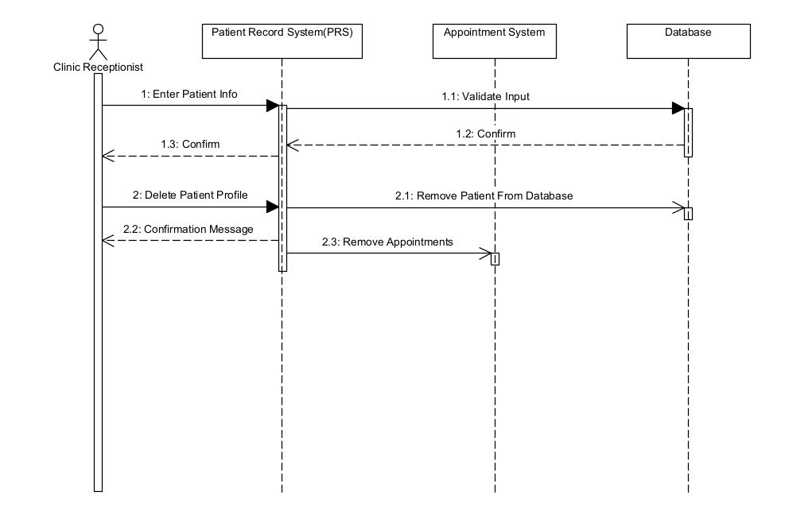

### 3.3.05 View Patient Records Sequence Diagram

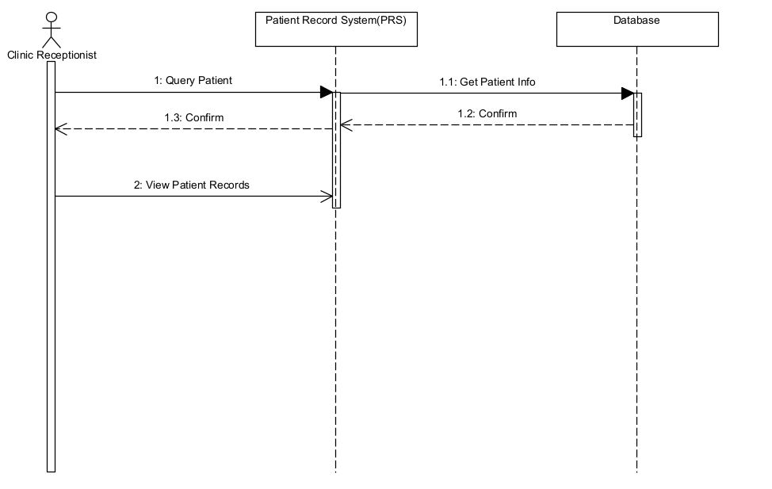

### 3.3.06 Issue Copay Sequence Diagram

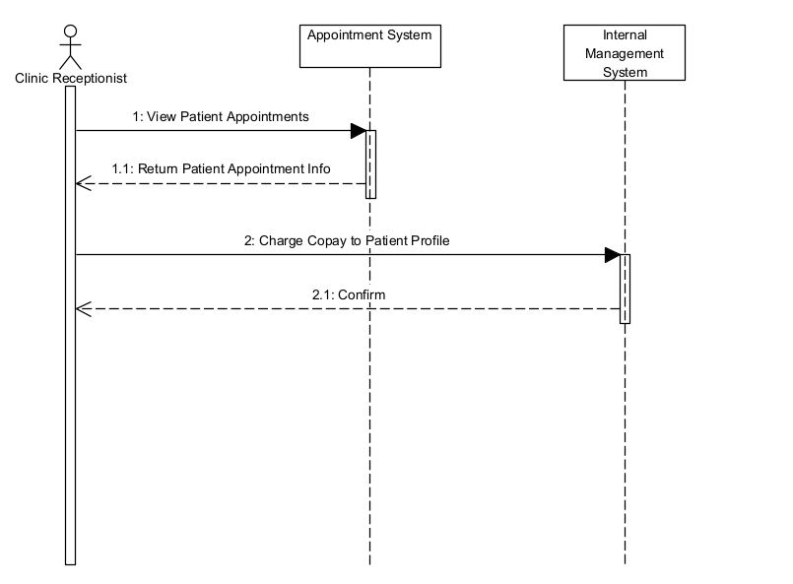

### 3.3.07 Manage Appointment Sequence Diagram

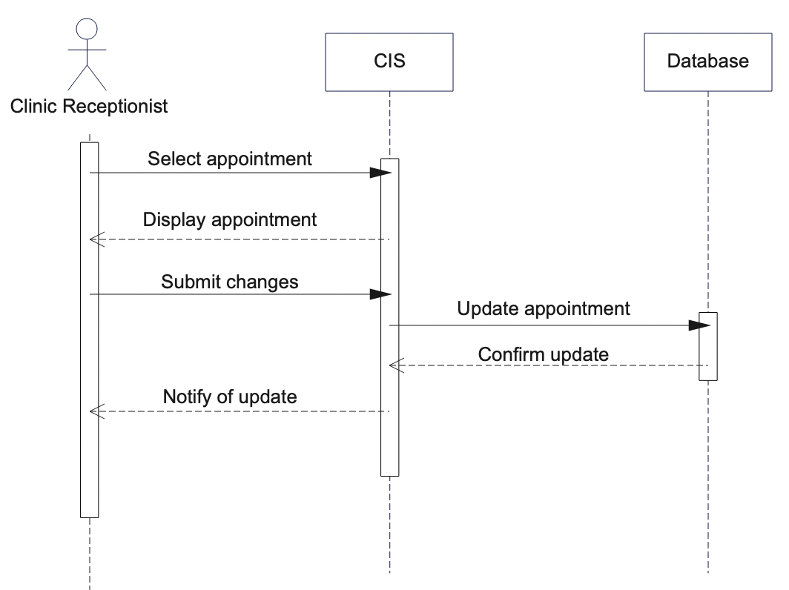

### 3.3.08 Add Appointment Sequence Diagram

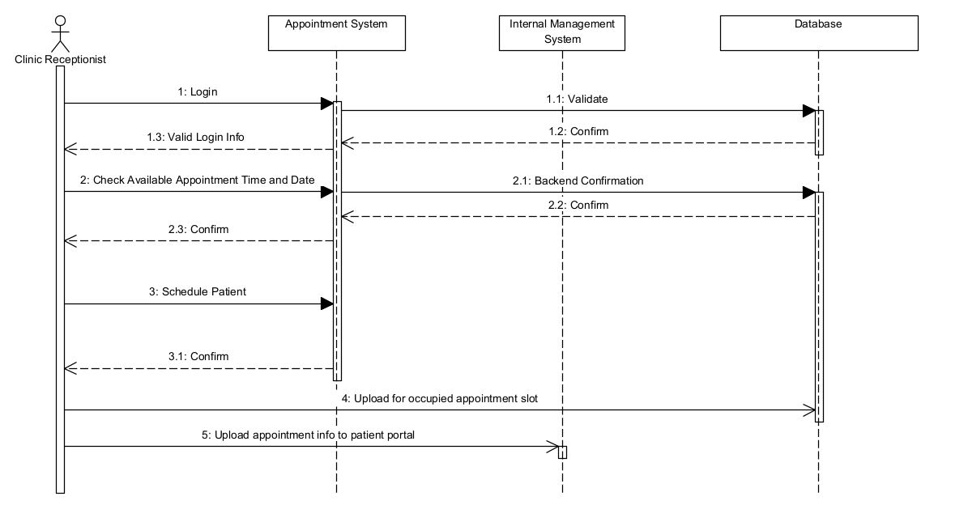

### 3.3.09 Delete Appointment Sequence Diagram

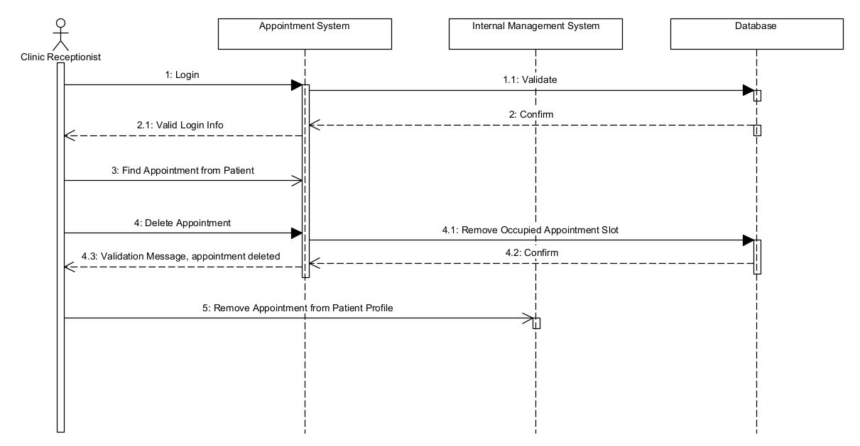

### 3.3.10 Prescribe Medicine Sequence Diagram

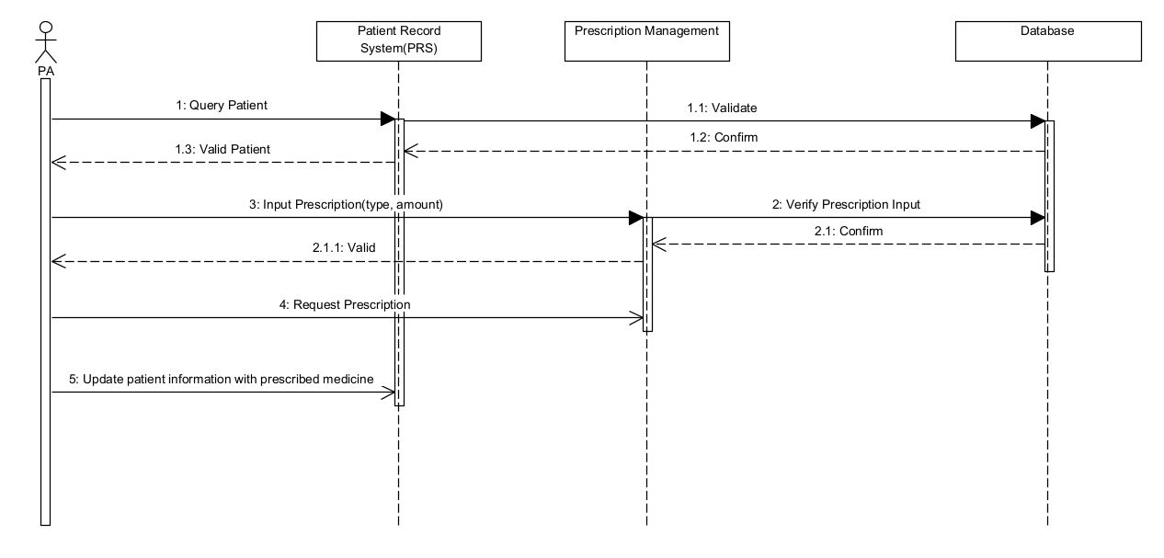

### 3.3.11 Issue Treatment Sequence Diagram

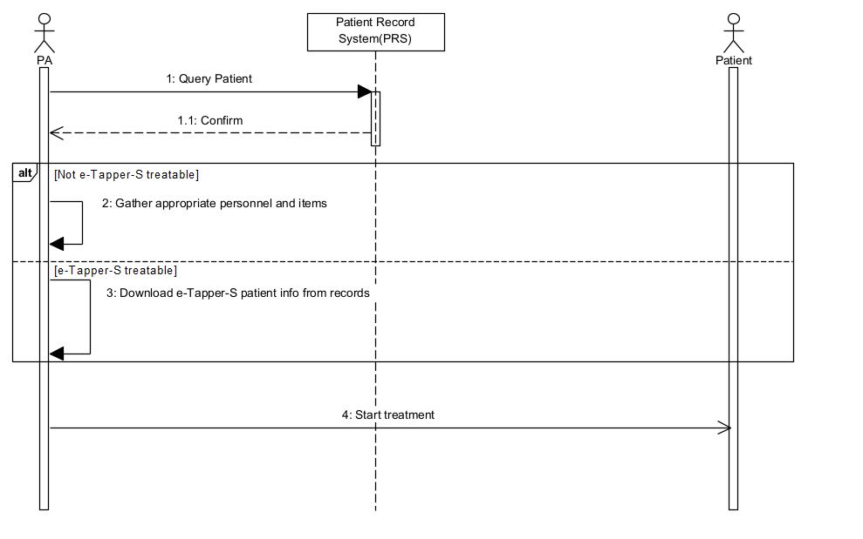

### 3.3.12 Create Referral Sequence Diagram

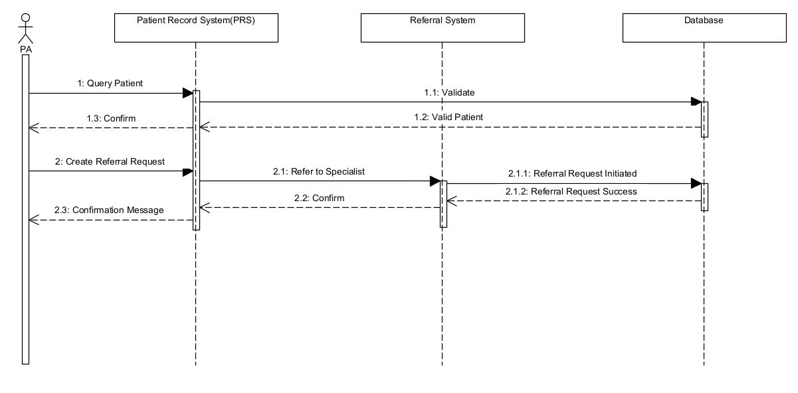

### 3.3.13 View e-Tapper-S Reports

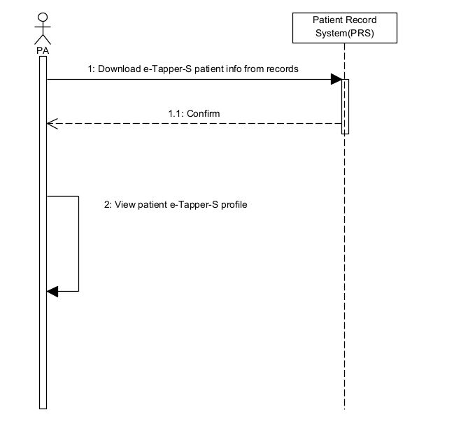

### 3.3.14 Request Appointment Sequence Diagram

### 3.3.15 Check-in Appointment Sequence Diagram

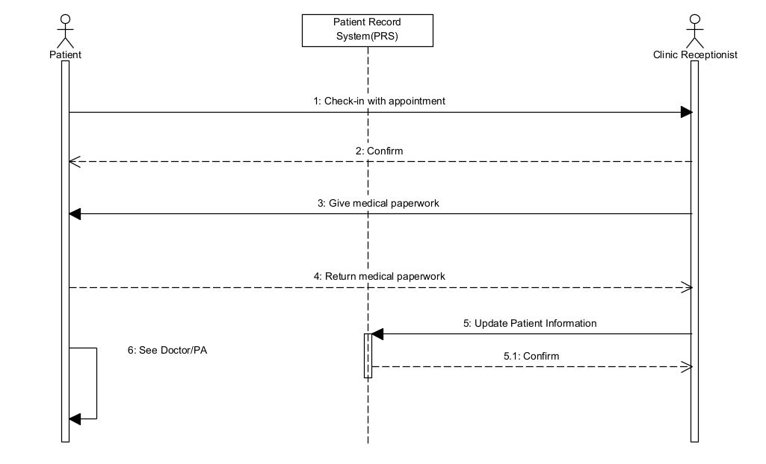

## 3.4 State Diagrams

### 3.4.00 Home Screen State Diagram

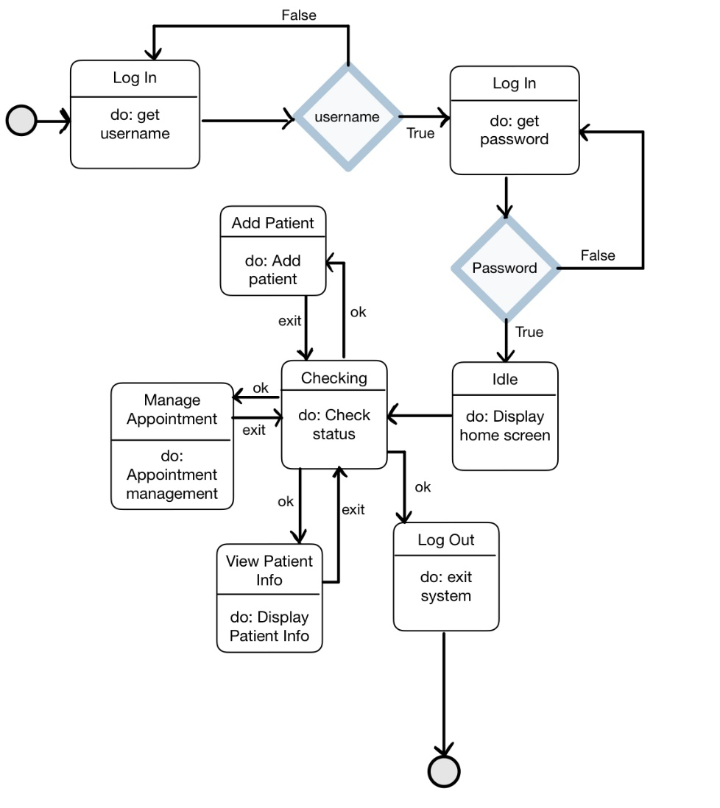

### 3.4.01 View Patient Info State Diagram

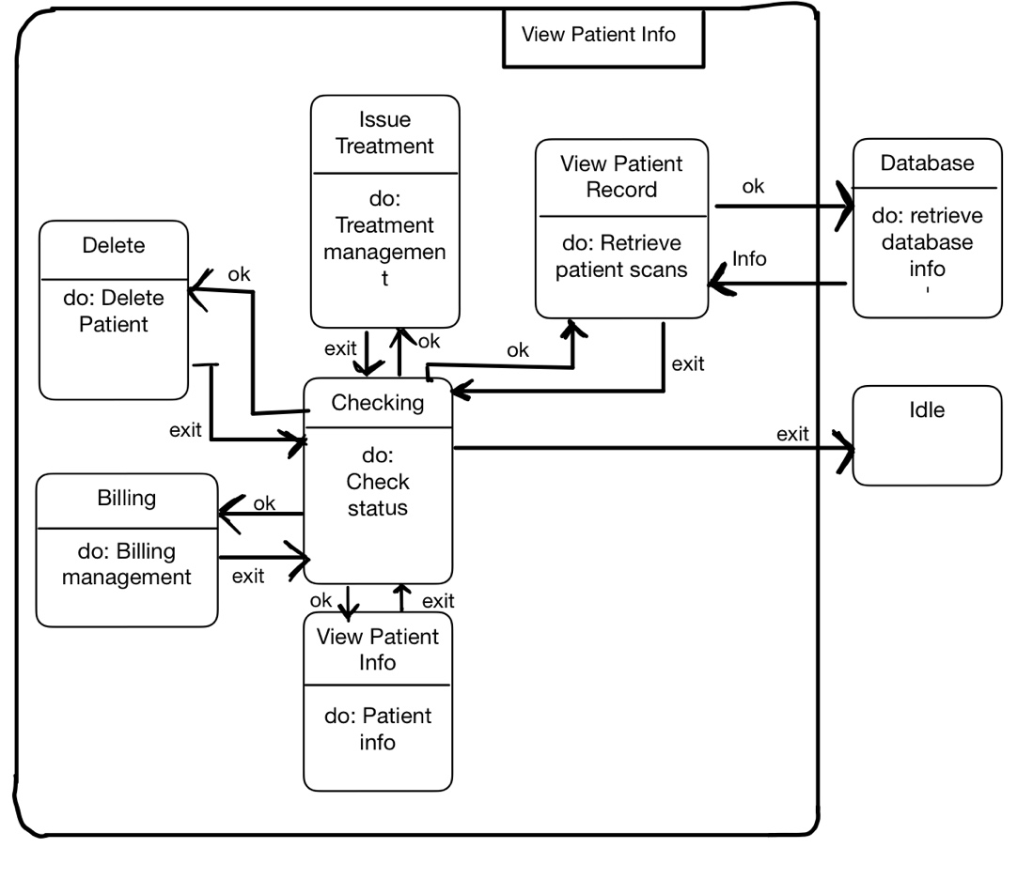

### 3.4.02 Add Patient State Diagram

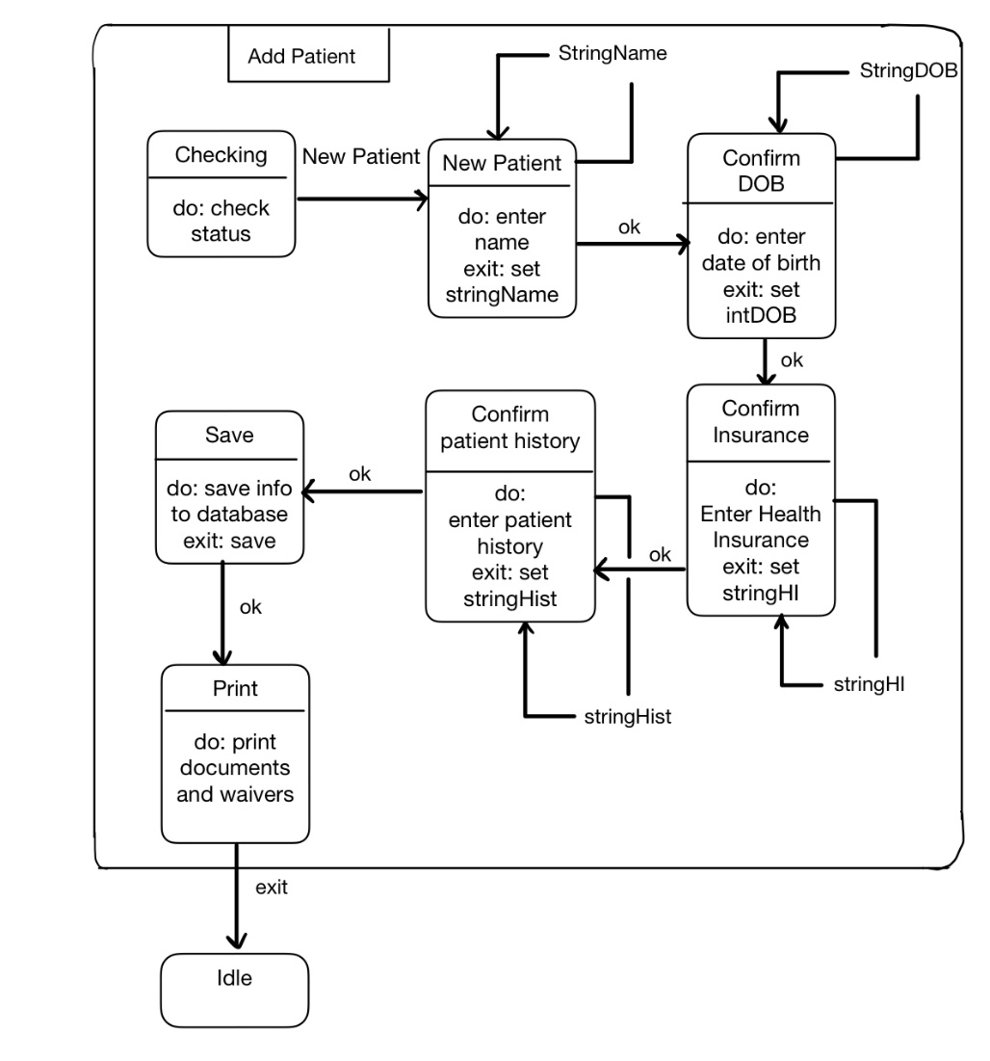

### 3.4.03 Delete Patient State Diagram

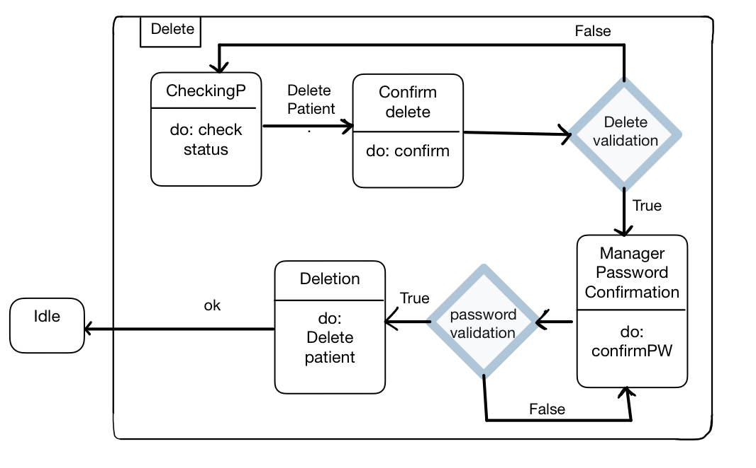

### 3.4.04 View Patient Record State Diagram

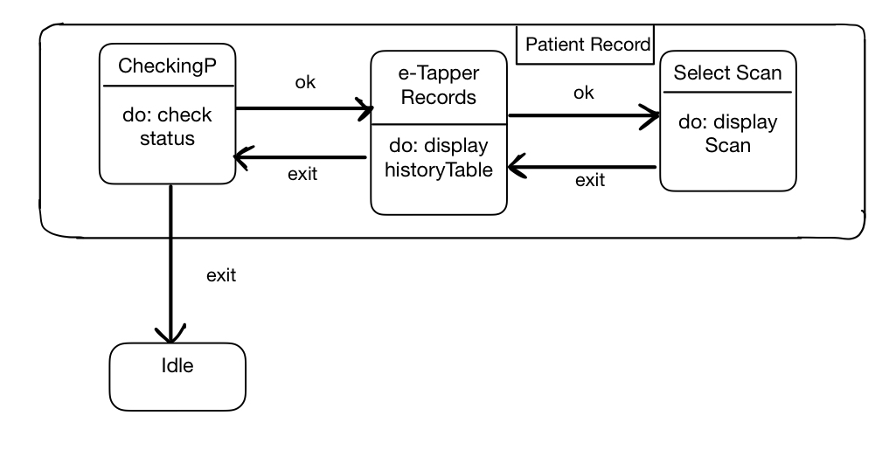

### 3.4.05 Patient Billing State Diagram

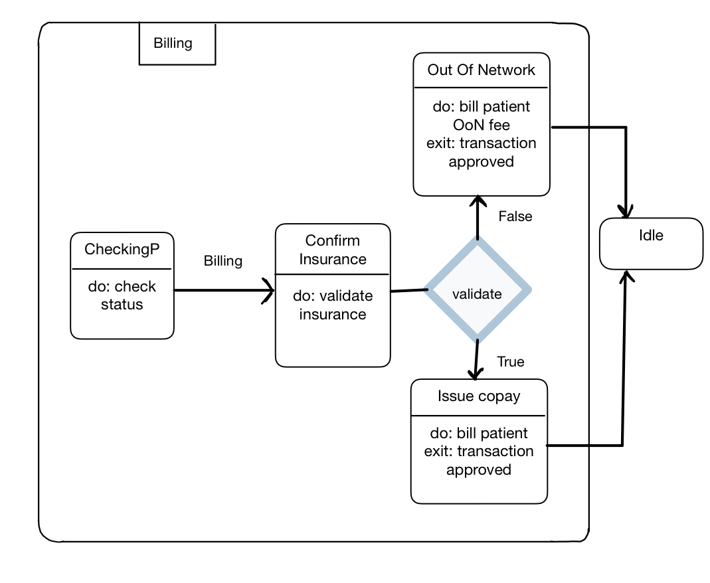

### 3.4.06 Manage Appointment State Diagram

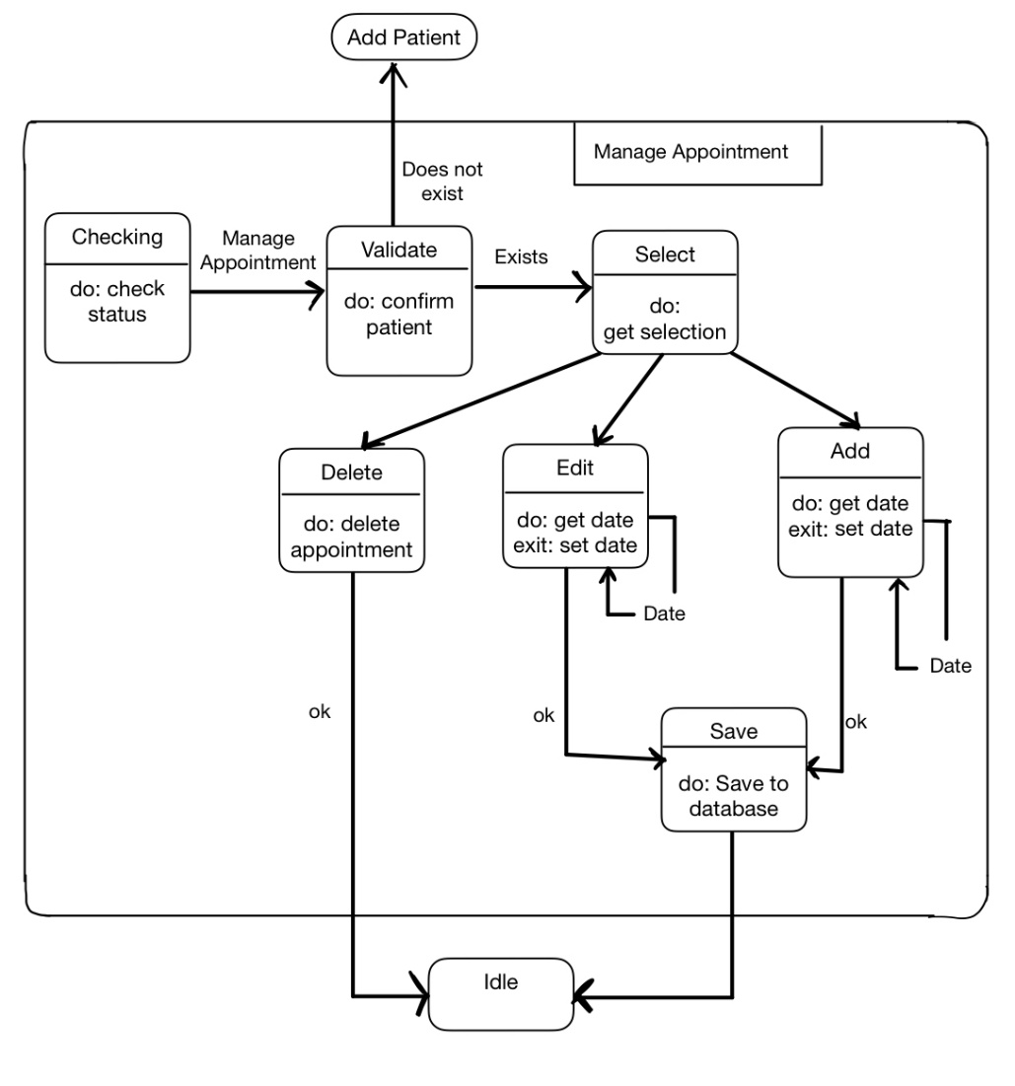

### 3.4.07 Issue Treatment State Diagram

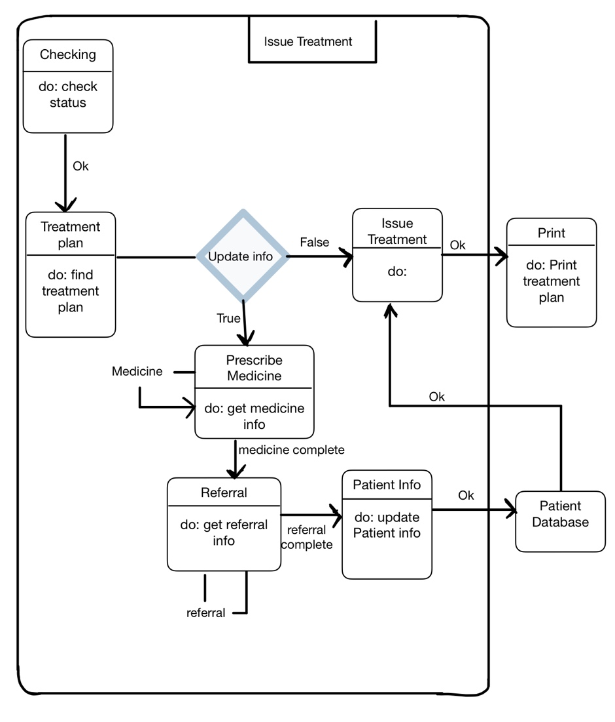

### 3.4.16 Request Appointment State Diagram

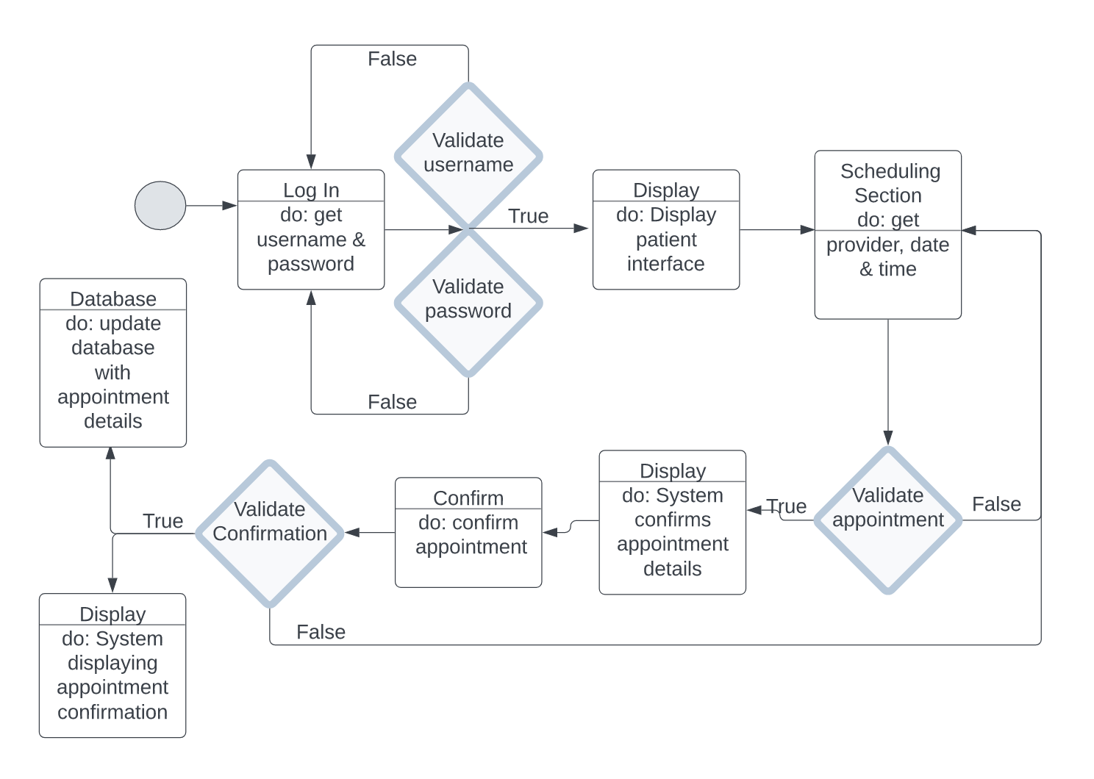

### 3.4.17 Check-in Appointment State Diagram

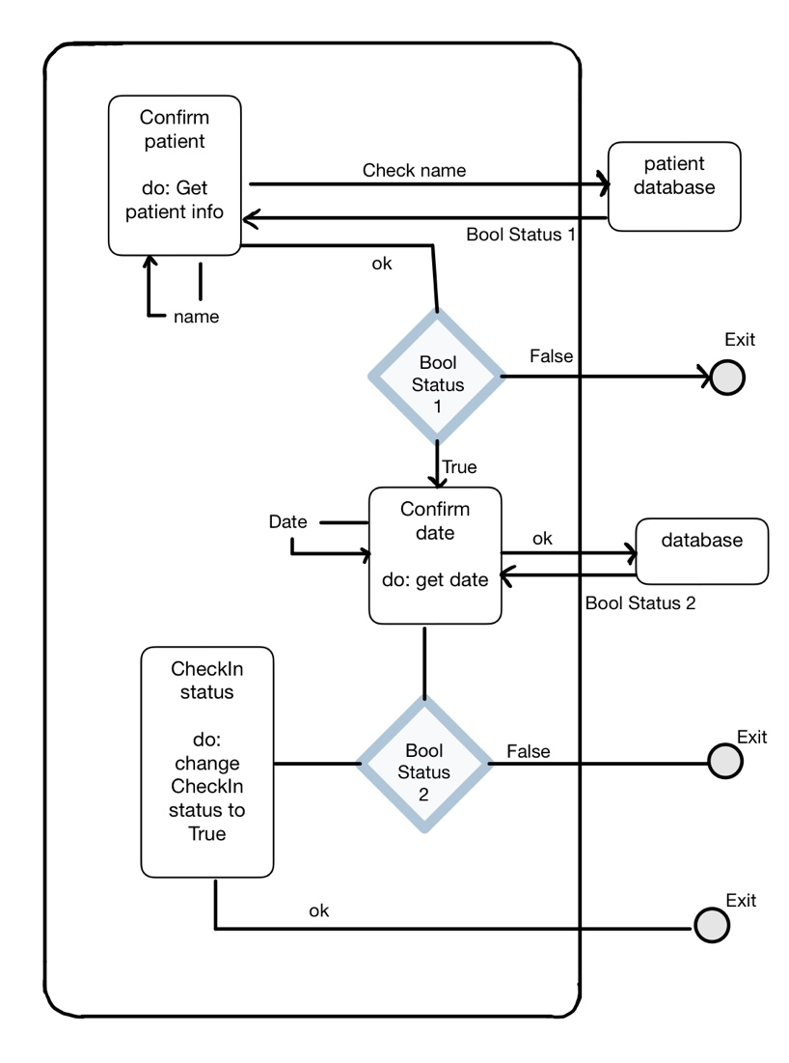

# 4.0 Implementation

### 4.1 Reuse

The development of the Clinic Information System will be based on component level reuse. Reuse of frameworks of previous enterprise software sharing highly similar characteristics of the Clinic Information System will reduce development costs.

### 4.2 Configuration Management

The development of the Clinic Information System will utilize the standard practices of Configuration Management. The development of the system will involve keeping track of multiple versions of the system components and ensure that changes made to components by different development teams do not interfere with one another.

The Clinic Information System will utilize multi-version development. To facilitate rapid deployment, several teams will be involved with the development of different versions of the system. This approach is illustrated through Figure 4.2.

Version control will be implemented through a Distributed System.

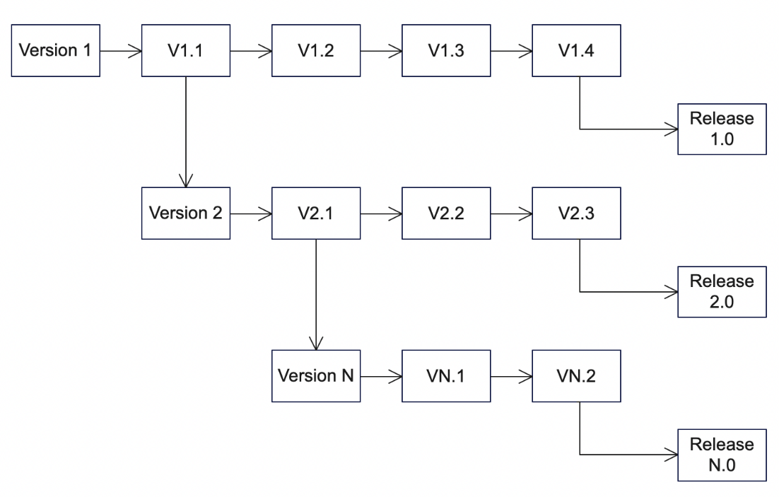

Figure 4.2

### 4.3 Host-Target Development

The Clinic Information System shall be developed in Java; thus, the target environment will be the Java Virtual machine. The development of a platform-independent system with high portability will save time and reduce costs.

# 5.0 Testing

### 5.1 Functional Requirements Test Scenarios

|  |  |  |  |
| --- | --- | --- | --- |
| Test Scenario ID | Requirement Ref/  TS ID ref | Test Scenario Description | No. Of Test Cases |
| TS_000 | 3.2.00 | Validate if the user can log in to the CIS. | 3 positive  2 negative |
| TS_001 | 3.2.01 | Validate if the user can logout to the CIS. | 3 positive  2 negative |
| TS_002A | 3.2.02 | Validate if the user can open the patient info module. | 3 positive  2 negative |
| TS_002B | 3.2.02 | Validate if the user can view a patient’s information screen. | 3 positive  2 negative |
| TS_003A | 3.2.03 | Validate if the user can open the Add Patient module. | 3 positive  2 negative |
| TS_003B | 3.2.03 | Validate if the user can add a new patient into the system. | 3 positive  2 negative |
| TS_004A | 3.2.04 | Validate if the user can open the Delete Patient module. | 3 positive  2 negative |
| TS_004B | 3.2.04 | Validate if the user can delete a patient from the system. | 3 positive  2 negative |
| TS_005A | 3.2.05 | Validate if the user can open the Records module. | 3 positive  2 negative |
| TS_005B | 3.2.05 | Validate if the user can open a patient’s records. | 3 positive  2 negative |
| TS_006A | 3.2.06 | Validate if the user can open the Copay module. | 3 positive  2 negative |
| TS_006B | 3.2.06 | Validate if the user can successfully process a copay for a patient. | 3 positive  2 negative |
| TS_007A | 3.2.07 | Validate if the user can open the Appointments Module | 3 positive  2 negative |
| TS_007B | 3.2.07 | Validate if the user can submit changes to an existing appointment. | 3 positive  2 negative |
| TS_008 | 3.2.08, TS_007A | Validate if the user can create a new appointment and that it is recorded into the system. | 3 positive  2 negative |
| TS_009 | 3.2.09, TS_007A | Validate if the user can delete an existing appointment from the system. | 3 positive  2 negative |
| TS_010 | 3.2.10, TS_005B | Validate if the user can prescribe medication to a patient and the prescription is recorded to the patient’s records. | 3 positive  2 negative |
| TS_011 | 3.2.11, TS_005B | Validate if the user can submit a record of a treatment provided into a patient’s records. | 3 positive  2 negative |
| TS_012 | 3.2.12, TS_002B | Validate if the user can create a referral for an existing patient. | 3 positive  2 negative |
| TS_013 | 3.2.13 | Validate if the user can open the e-Tapper-S module. | 3 positive  2 negative |
| TS_014 | 3.2.13 | Validate if the user can download a patient’s e-Tapper-S reports that have been uploaded into the system. | 3 positive  2 negative |
| TS_015 | 3.2.14 | Validate if the user can access the website's appointments page. | 3 positive  2 negative |
| TS_016 | 3.2.14 | Validate if the user can submit an appointment request at a specified time and date. | 3 positive  2 negative |
| TS_017 | 3.2.15, TS_015 | Validate that the user can check-in to an existing appointment | 3 positive  2 negative |

### 5.2 Release Testing

Release testing will take place once the product is in the late stages of development by utilizing fake patient data, inter-service network of doctors, and an appointment system with limited availability to test the non-functional and functional requirements of the system by separate team that was not involved in the development process. The team is to test every scenario listed in section 5.1 while also providing the functionality of the requirements found in section 3.1.

### 5.3 User Testing

Acceptance testing will be utilized for this system due to the environment of the application. To accomplish the user testing, the development team will bring in a small group of individuals to represent patients, several clinic employees that are involved in the day-to-day operations, and doctors to set up the most realistic environment possible and get the system in the hands of the targeted users. To increase the reliability of the testing, automation testing will also be utilized to make sure common tasks such as requesting/canceling appointments reach their respective passing criteria with the best coverage.

### 5.3.1 Acceptance Criteria

|  |  |  |  |
| --- | --- | --- | --- |
| Acceptance Scenario ID | Requirement Ref | Description | Passing Criteria |
| AC_000 | 3.2.00 , 3.2.01 | Users shall be able to successfully login/logout of the CIS. | 99% |
| AC_001 | 3.2.02 , 3.2.03 , 3.2.04 | The clinic shall be able to successfully view, add, delete, and modify patient information. | 99% |
| AC_002 | 3.2.05 | The clinic shall be able to view patient records on file. | 99% |
| AC_003 | 3.2.06 | The clinic shall be able to issue the appropriate bill/co-pay to the patient. | 99% |
| AC_004 | 3.2.07, 3.2.14 | The patient shall be able to request, cancel, and manage appointments with the clinic. | 99% |
| AC_005 | 3.2.15 | The patient shall be able to successfully check-in to their appointment. | 99% |
| AC_006 | 3.2.07, 3.2.08, 3.2.09 | The clinic shall be able to manage, add, and delete any patient’s appointment. | 99% |
| AC_007 | 3.2.10 | Only the PA or user with a doctor’s credentials shall be able to successfully prescribe medicine to a patient. | 100% |
| AC_008 | 3.2.11 | Only the PA or user with a doctor’s credentials shall be able to issue a treatment plan to a patient. | 100% |
| AC_009 | 3.2.12 | The clinic shall be able to create a referral to the inter-service network of specialists and hospitals. | 100% |
| AC_010 | 3.2.13 | Only the PA or user with a doctor’s credentials shall be able to successfully view e-Tapper-S reports. | 100% |
| AC_011 | 3.1.00 | When using the CIS GUI, there should be no more than a 1sec delay when changing screens | < 1sec |
| AC_012 | 3.1.06 | Patient data shall be encrypted to ensure security. | Must pass all most common penetration tests agreed upon from the stakeholders and security team |
| AC_013 | 3.1.08 | The application must be easy to use for all users | >95% acceptance rate. Will ask users a series of questions and score their results from 0-100. |